Capstone Report

Duc Phu Pham

Arkansas Movie Database

**Arkansas Film Commission  
Arkansas Movie Database**

**Project:**Arkansas Movie Database

**Sponsoring Organization:**

Arkansas Film Commission

**Sponsor Contact Information:**

900 W Capitol Ave Suite 400, Little Rock, AR 72201

Phone: (501) 682-7676

**Students:**

Duc Phu Pham

**Faculty Advisors:**

Dr. Elizabeth Pierce & Mr. Bruce Bauer

**Project Begin Date:**

August 24, 2020

**Project End Date:**

May 14, 2020

**Table of Contents**

Client Introduction………………………….……………………...3  
Analysis Work Performed………………………………………….4-5

Design & Development Work Performed………………………….6  
Professional Responsibilities…………………………….…………7  
Team Work…………………………………………………………7

Integration……………………………………………………….….8

Summary……………………………………………………………9  
List of Reference Sources……………………………………..…..10  
Appendices………………………………………………………...11

**Client Introduction**

The Arkansas Film Commission is a profit organization serving the State of Arkansas with a statewide, team approach to production, they provide producers with seamless, single contact access to everything and everyone the state has to offer, ensuring the most efficient, effective, and economical experience possible.

The Arkansas Film Commission is located at 900 W Capitol Ave Suite 400, Little Rock, AR 72201. More information on the organization can be found on their website: <http://www.arkansasproduction.com/>

**Analysis of Work Performed**

**A. Describe the Problem or Challenge Facing the Client**

The Arkansas Film Commission website currently offers list of movies and actor/actresses that has ties to the state of Arkansas, but the website is a bit outdated and do not provide a comprehensive and user-friendly experience that cater to their targeted audience. Thus, this project was initiated to combat that issue.

The sponsor would like to create a web-based database of movie and actors/actresses that have relation to the state of Arkansas for use by their targeted audience.

**B. Evaluate the Current State surrounding the problem or issue**

The website is expected to utilize HTML5, CSS, JavaScript, and jQuery. The database will be pull from The Movie Database to ensure accuracy. A rough design has been created and received feedback from Mr. Thomas Wallace:

- A brief introduction of the website to be presented in the home page.

**C. Describe Client’s Desired Future State**

The web-based database is expected to have the following requirements:

* Ability to browse and search the database for movies and actor/actresses that has ties to the state of Arkansas
* Database must be pulled from The Movie Database API
* Clean, sleek, and user-friendly design
* Maintain security so that only authorized users can modify the data
* Add additional enhancements as needed

**E. Develop proper requirements documentation that provides a detailed plan for what your team plans to do to move from the current state.**

Below is our detailed plan for Capstone I to take the project from its beginning state to what the client wants in the future.

* Week 1-5 Meet with Mr. Bauer & Dr. Elizabeth Pierce to discuss current state of project and develop requirements document and develop design document.
* Week 6-7 Research Requirement
* Week 8-10 Develop rough design and complete document report

We have met all our goals in our plan Capstone I. Below is our detailed plan for Capstone II to take the project form where we left off after Capstone I to what the client wants in the future.

* Week 11 Meet with Mr. Bauer & Dr. Elizabeth Pierce to discuss current state of project
* Week 12-18 Work on the website and database
* Week 19-20 Testing

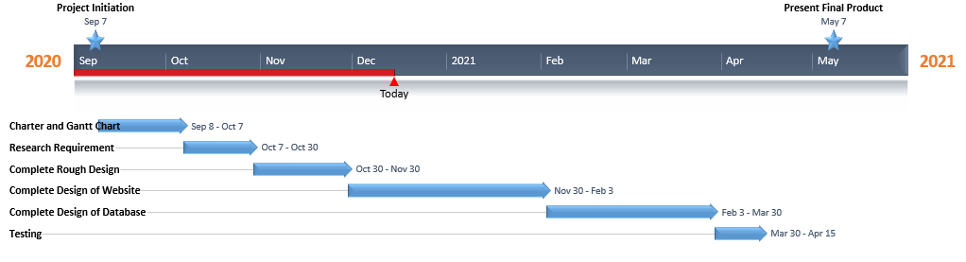

**Design and Development Work Performed**

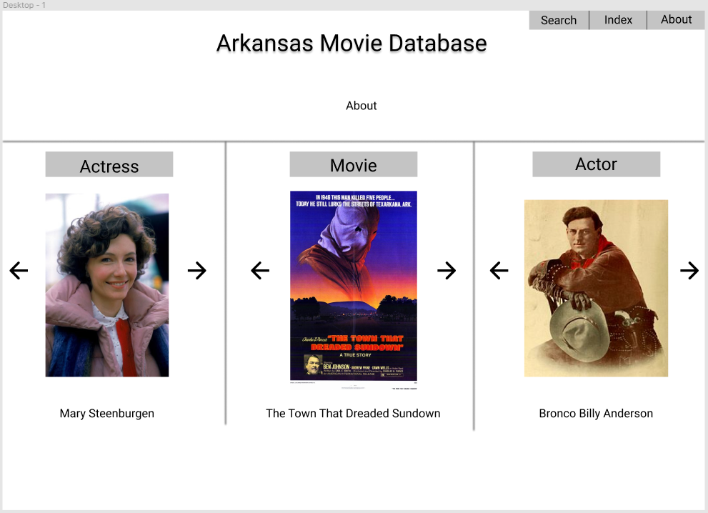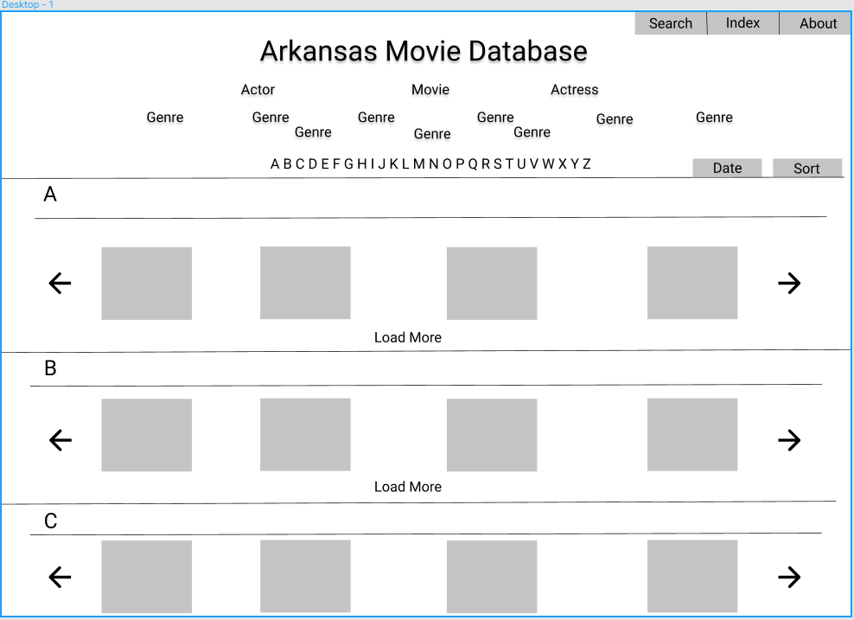

**Professional Responsibilities**

Professional responsibilities that I will have to take into consideration when working on the project is to keep up with the timeline that has been set out and be mindful of user privacy and disclaimer for the use of intellectual property where applicable.

**List of Reference Sources**

Javascript Tutorial found at <https://www.w3schools.com/js/default.asp> .

JQuery Tutorial found at <https://www.w3schools.com/jquery/default.asp> .

JQuery Reference found at <https://jquery.com/> .

API Tutorial found at <https://developers.themoviedb.org/3/getting-started/introduction> .

Movies/Actors/Actresses research found at <https://www.themoviedb.org/> .